

**Knowledge Mapping and Data Visualization**------------------------------------------------------------------------

Covid-19 Project  
  
Hospital Occupancy Rates in Turkey During the Covid-19 Process

**H.Kemal İLTER**  
--------------------------------------------

**Prepared by**

**Duygu Uçgun 16030411038**

**Abstract**   
 In this project, I will examine the hospital occupancy rates in the Covid-19 process in Turkey. I will examine the social and economic effects of 'hospital occupancy rates', which is one of the daily available data, on human health. In addition, I will examine the different point of view regarding the management of the process by healthcare professionals and authorities. Was the reason for the increasing hospital density rates in the epidemic process managed in Turkey was the mismanagement of the epidemic or was it the natural course of the epidemic? We can learn the answer to this question together. In this process, I aimed to examine the problems experienced by people in hospitals, the attitude of hospital staff and also the behavior of patients. Thanks to the knowledge and experience I have gained from my daily life, I will present this project to you in the best possible way. I started social studies on people who have been careful since the beginning of the pandemic period and who were vaccinated during the pandemic period, who had or did not have covid-19, and who have never had covid-19. In line with the information I have acquired in this project, I will find the most accurate way to specify hospital density rates on data visualization and add it to my project.

The data I will need while doing this project; Daily deaths in Turkey, bed occupancy rate in hospitals, rate of intubated patients. I will examine these data in 3 different time intervals. April 2021 April 2020 and December 2021. I'll make a comparison with different countries where necessary. For a detailed examination of the Covid-19 process, we need to reach the drugs used and the treatment methods in hospitals. However, since this is a current and ongoing issue, I do not find it right to talk too much about the Covid-19 drugs and different treatment methods used. But again, brief information about these factors should be given;

* ***Plasma blood treatment:*** *Plasma blood treatment was applied to appropriate intensive care patients at certain time intervals, and this plasma blood treatment was approved by some doctors, but not by others. For plasma blood treatment, the Covid-19 patient must be in the first 10 days. It is applied in patients who do not respond to antibiotic treatment.*
* ***Intensive care treatment with a different drug:*** *some patients were given an antibiotic drug treatment that was not approved by the Ministry of Health in Turkey. The Ministry of Health did not approve because it was uncertain and had many side effects.   
  Despite this, some conscientious intensive care physicians started to talk about this drug treatment with the authority of intubated patients' relatives. If the relatives of the patients had financial means, they would buy this drug personally and deliver it to the doctor. Of course, the procedures applied for this were different. It was done with the consent of the relatives of the patients. Sometimes, the values ​​of the patient were transmitted to the health ministry and demanded this drug for the patient, but the health ministry did not approve this drug according to the values ​​of the intubated patients. Because the drug had harmful effects on the defense mechanism.*

I can access these data from many different places, but I have planned to actively collect data on 5 different platforms for certainty.

1. I will access the Digital Transformation Office website, which has been recently opened by the Presidency of the Republic of Turkey.
2. Daily data published by the Ministry of Health of the Republic of Turkey during the pandemic process.
3. The monthly reports of the Turkish Medical Association.
4. Data published by the World Health Organization.

While obtaining these data, I was impressed by the disagreements that arose due to Turkey's political and economic situation. I also had to examine and evaluate the data of the Turkish Medical Association, which opposed the data announced by the Ministry of Health. With the chaos, obscurity and shock effect of the epidemic that emerged during the pandemic process, many different approaches emerged. There are many different newspapers, websites, different institutions and organizations where I can access these data. I encountered a lot of information pollution. I tried to use the resources that are on Turkey's agenda.  
 Finally, there are some data visualization tools that I will use while doing a detailed analysis of this project. I chose to use the Datawrapper and Visme tools as they are easy to access.  
  
 **Introduction** Coronaviruses are a type of virus that usually occurs in mammals and birds. Covid-19, a new type of this virus previously seen in animals, was first seen in Wuhan, China in December 2019. With the rapid spread of this virus, it has affected the whole world in a short time. In March 2020, it was declared a pandemic by the World Health Organization. During this global epidemic period, the countries' history of the epidemic was different. In Turkey, the first case was announced on March 11, 2020. Then, with the effect of the epidemic, measures were taken across the country. Symptoms of coronavirus were published as fever, cough, and shortness of breath. Later, the loss of smell and taste was added.  
 The coronavirus has affected our lives in many ways; psychological, social, economic and most importantly health. During the pandemic period, the number of people in the world who are not affected by the pandemic is now quite low. In line with the measures taken, people started to stay in homes, wear masks and follow distance rules. With this process, health problems started to emerge. People were very worried after the first case was reported in Turkey in early 2020. Sales of disinfectants, masks and cologne increased. Everything changed in Turkey overnight. The measures taken started to increase day by day and a curfew was imposed. During this pandemic period, the first mass affected was 65 years of age or older, so this elderly population was treated in a very specific way. While the measures were relaxed, the control was still the same for 65 and above. It was thought that those with chronic diseases were more affected. Asthma patients, diabetics, dialysis patients, cardiovascular patients and cancer patients were particularly careful. However, this was not known at the beginning of the pandemic. As people experienced this, they began to tell each other about their experiences. There was no exact information. Even the treatment method used in Turkey was not clear. After a certain period of time, the treatment process was concluded and a 'fillation' team, namely a contact follow-up team, was formed. In order to facilitate the management of the coronavirus measures and the pandemic process, the Coronavirus Science Board was established in Turkey. Since the number of cases was low in this process, the epidemic was brought under control in the first place. However, this took a very short time. Then, with the increasing number of cases, hospital occupancy rates started to increase. When people caught coronavirus searched the relevant unit, they could not find a solution immediately. When patients with coronavirus symptoms sought help by calling the 112 emergency line, they could not find a solution. Contact tracking teams were not working at the same pace in every city.

**Scenario** In order to examine the coronavirus process more closely, I will talk about the experiences I witnessed and gained during this process. In this project, I would like to examine and explain in detail the hospital process of my father, whom I lost 4 months ago due to coronavirus. Our patient aged 65 and over was also diabetic. Symptoms had started in November 2020 with a severe cough. Because he was acting very carefully, no one around him suspected it would be covid-19. The same patient had been treated for bronchitis a year ago. As the cough naturally increased, they thought there was a problem with bronchitis. During this period, the patient spent 1 week with his loved ones, not knowing that he was covid. A person he met after this week reported that he had a coronavirus. Due to this situation, our patient was accepted as a 'contact person'. Those who came into contact had to go into quarantine at home. It happened like this and the quarantine process started. Our patient suddenly fainted 3 days later. The coronavirus test was also performed after the blood test of the patients and their relatives who went to the hospital with suspicion. Doctors had prescribed 'coronavirus drugs' without waiting for the result of the coronavirus test. He also gave antibiotics. The patients and their relatives, that is, the contacts, went to their homes and waited for the test results. When they saw the positive result the next day, they immediately called the relevant people and reported the situation. They had become Covid19. The contact tracking team came home to check. But they stayed away and looked at the family and said 'you're okay, no problem'. However, there was another disabled patient at home and that person did not have a test. 3 covid19 cases and 1 contact person lived in the same house. During this process, they behaved consciously. It has been said that nutrition is very effective in the healing process and vitamin D is required. Therefore, they met their vitamin D needs by sunbathing. They paid attention to the consumption of fruits and vegetables. In the meantime, they could not buy this drug from the pharmacy because the antibotic drug prescribed by the hospital was not approved. They just drank coronavirus medicine. At the end of the 3rd day, our patient could not stand it anymore and called the emergency 112 line and asked for help. The emergency team came and said that the patient's saturation was very low and that he had to go to the hospital urgently. The patient was being taken to Adana City Hospital by ambulance. However, when he learned that the capacity of this hospital was full on the way, he was taken to Adana Yuregir State Hospital. There was nobody with him. When the doctors saw the patient's condition, they immediately began to look at him. Thus, the hospital process began. After the last 10 days of treatment, the patient would then be taken from the service room to the intensive care room.

Doctors stated the situation urgently. But the intensive care capacity of the hospital was full. As a result of the death of a patient in the intensive care unit, a new patient could be admitted to the intensive care unit. The patient we mentioned had to wait for a long time to be admitted to the intensive care unit due to his age. Because the doctors were giving priority to younger patients because the patient was 68 years old. The patient, who had to be taken to the intensive care unit, waited in line for 1 day. Then it came out 3 hours later, the doctors said there was no need. Relatives of patients asked doctors whether there would be 'plasma treatment'. Doctors said that this treatment can be done within the first 10 days. The fact that the relatives of the patients were not informed within the first 10 days was entirely due to the hospital occupancy rates and the health workers working under extreme difficulties. There were at least 300 patients for whom a doctor was responsible. Therefore, doctors had difficulties in communicating each patient's condition to their relatives. Doctors could not be reached during the day for information purposes.  
 Doctors said that as time passed, the patient's condition worsened and that he had to be referred to another hospital. In this hospital, they directly talked about a different drug. However, this drug was not approved by the Ministry of Health in Turkey, it was not a risky and reliable drug. This drug was just a possibility. As a result of the tests performed at the new hospital, we learned that the patient's corona test was no longer positive. But that didn't mean healing. As a result of the examinations, other diseases of the patient emerged. Diagnoses of kidney failure, heart failure, etc. were made. The patient remained intubated for 4 days and then died. Relatives of the patients were under follow-up from the beginning of the process and could clearly see the deficiencies and omissions. The only thing that could be seen as a major reason in this process was the uncontrolled increase in hospital occupancy rates. Therefore, in this research, I will examine the hospital occupancy rates in Turkey.  
  
**Methodology**  
 Turkey was one of the countries that saw the first case during the pandemic process. It cannot be said that this pandemic, which started in Turkey in March, was taken under control at first. The country's doctors, ministry of health, nurses, pharmacists and hospital staff had begun a process that they were completely unfamiliar with. Towards the middle of the pandemic period, while the health systems of many countries were collapsing, Turkey was trying to take control in a dynamic and powerful way. Prohibitions, restrictions and mandatory quarantines were introduced without slowing down.   
 Although it was at the beginning of this epidemic period, it was one of the times when it was controlled. Restaurants and cafes and many social activities were restricted. There was no proper treatment method in Turkey and people were very afraid of going to the hospital, especially of getting corona. Just in this process, the occupancy rates in hospitals did not increase much and the situation in Turkey was progressing in a controlled manner.  
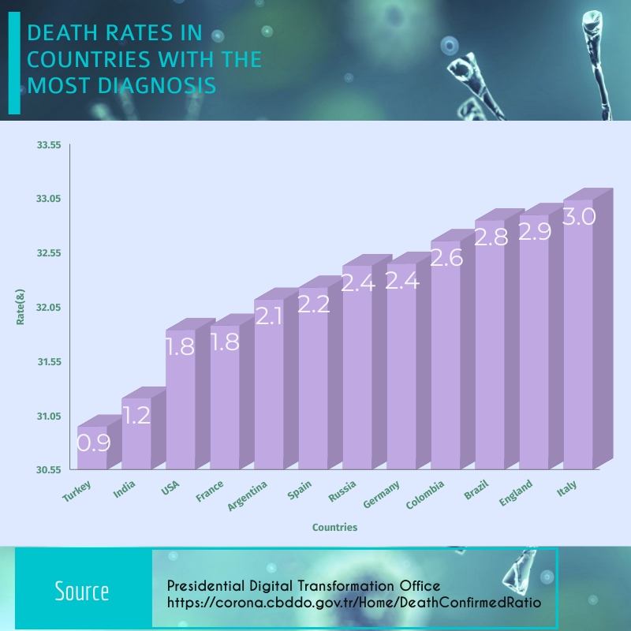  
We can see this situation from the death rates in the chart above, the pandemic was under control in Turkey.  
 As the reason for the controlled progress of the epidemic in Turkey, we can show that the health service is better than other countries. The capacity of the hospitals in Turkey and the number of health workers were quite sufficient when examined before the pandemic. Compared to other countries, Turkey was one step ahead in this regard.   
 According to a news published on Independet Turkey website, we can see this situation more clearly when Turkey's hospital bed capacity is compared. According to the news, the data are in the Organization for Economic Development and Cooperation (OECD) and the EU Statistics Office (Eurostat) in 2017. The data includes the 'number of hospital beds' and 'hospital beds per 100 thousand people' rates of countries.metin içeren bir resim

Açıklama otomatik olarak oluşturuldu  
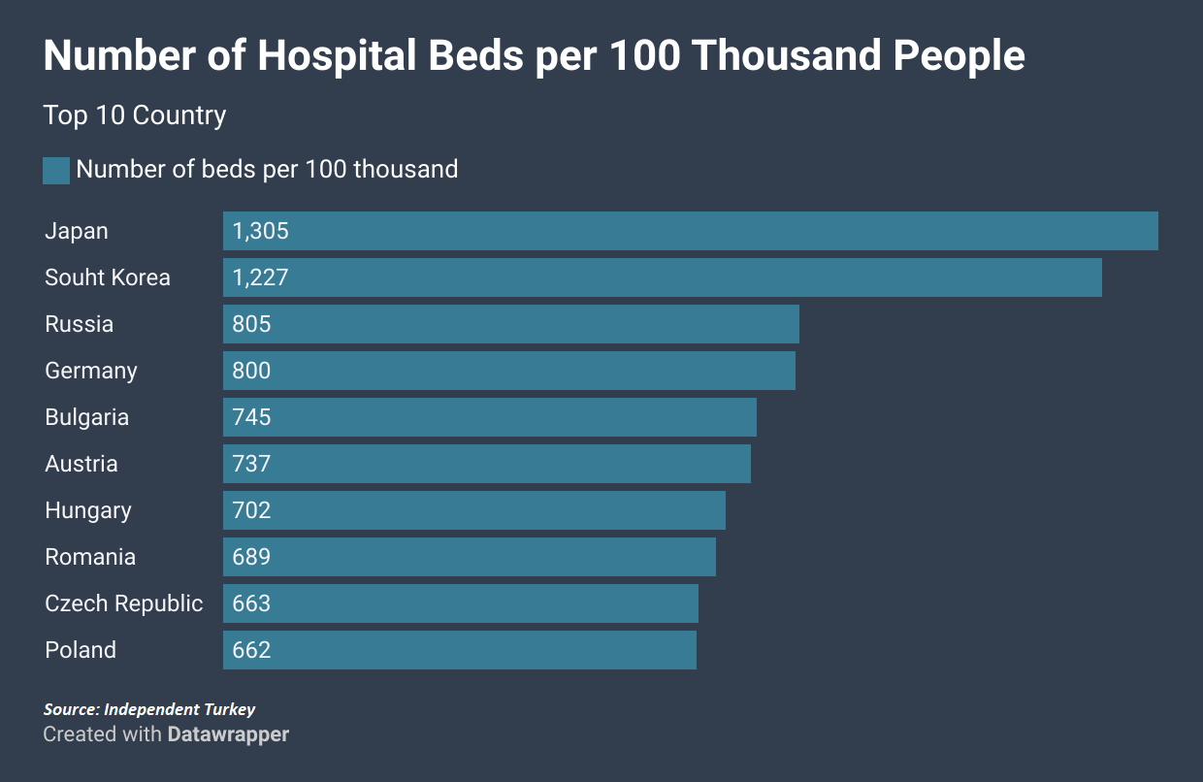  
  
  
 When we look at the data at the beginning of the epidemic, we can see this very clearly. The situation in Turkey in April 2020 was not scary. According to the data published by the Ministry of Health, the pandemic process was progressing successfully.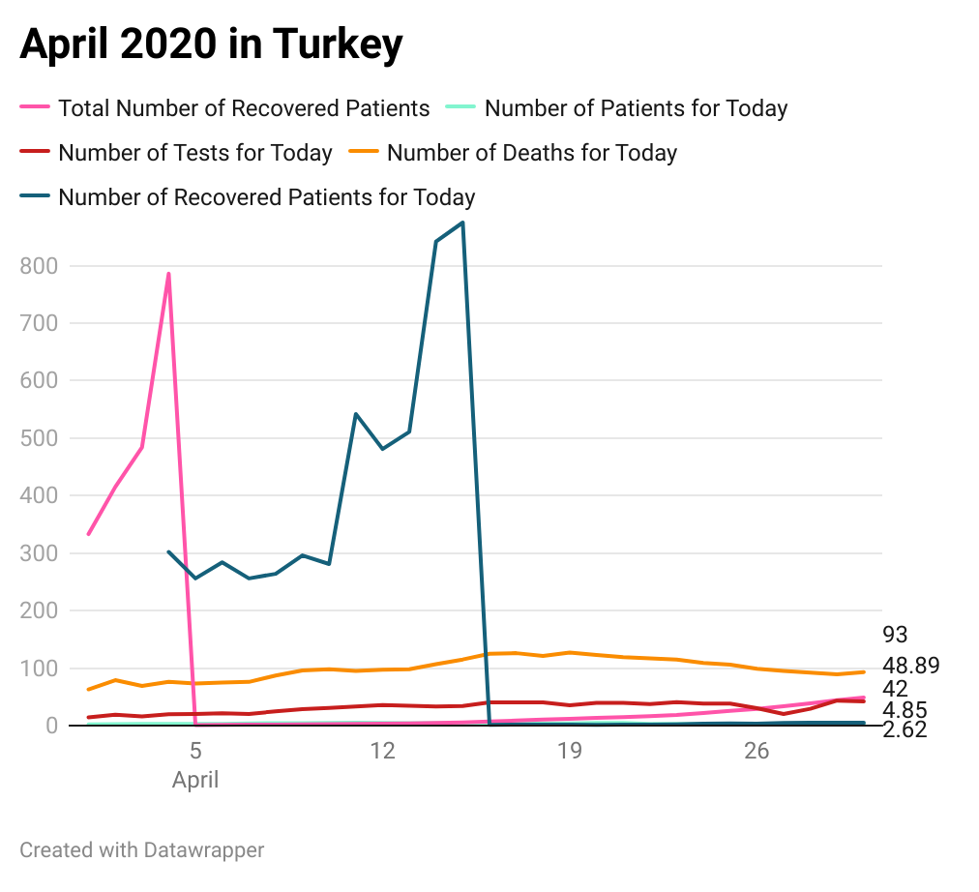  
 Then, economic and social problems began to emerge in Turkey. For this reason, the restrictions were gradually reduced. Travel restrictions were lifted, restaurants were opened. The tourism season had arrived and after the decreasing controls in Turkey, everyone started to go on holidays. This process lasted approximately between June and October. Tourism was a serious economic resource and this sector could not be prevented. But despite all this, it was difficult to control people, and that's why the epidemic got out of control just after this period. During this period, while the pandemic was under control in some provinces in Turkey, it was increasing suddenly at times. The factors that cause this; tourism, geographical location, immigration, population density.   
  
 We can say that the pandemic in Turkey is out of control, especially during the return of Turkish citizens living abroad to Turkey. After the normalization process, people lost their faith and fear of the corona virus. The measures were reduced. However, there was also a need for self-control of people. Medication began to progress from home. Quarantine processes were determined as 14 days. But people had lost their self-control and faith in the pandemic. We can see the results of all these very clearly in December 2020.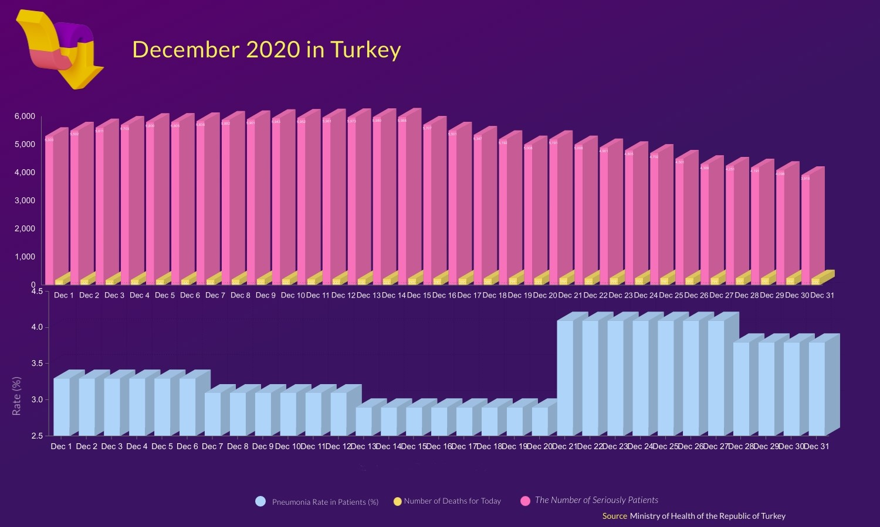  
 In December, the pandemic was completely out of control, especially in some parts of Turkey. As time passed, people began to be affected psychologically too much. This situation increased the number of applications to hospitals, the number of tests performed, the number of cases and the hospital occupancy rates.  
 The pandemic, which went out of control at the beginning of the year, had become uncontrollable. Despite this, people were able to gain immunity due to the length of the process. People began to learn more and more information as time went on. Some people have had the coronavirus multiple times. It began to be seen that some people did not comply with the measures at all. In addition to all these, the pandemic, especially hospital workers, had begun to affect people psychologically. For this reason, people began to gradually reduce going to the hospital. As a result of the researches, even people's belief in the corona virus decreased. The world-wide information pollution had begun. In April 2021, many measures were taken in Turkey. But it has become very difficult for people to keep them at home anymore.   
Most people did not comply with the measures. We can see the results of this very clearly. However, when we compare it to December 2020, when Turkey lost control, we can say that Turkey was in good shape in April 2021.  
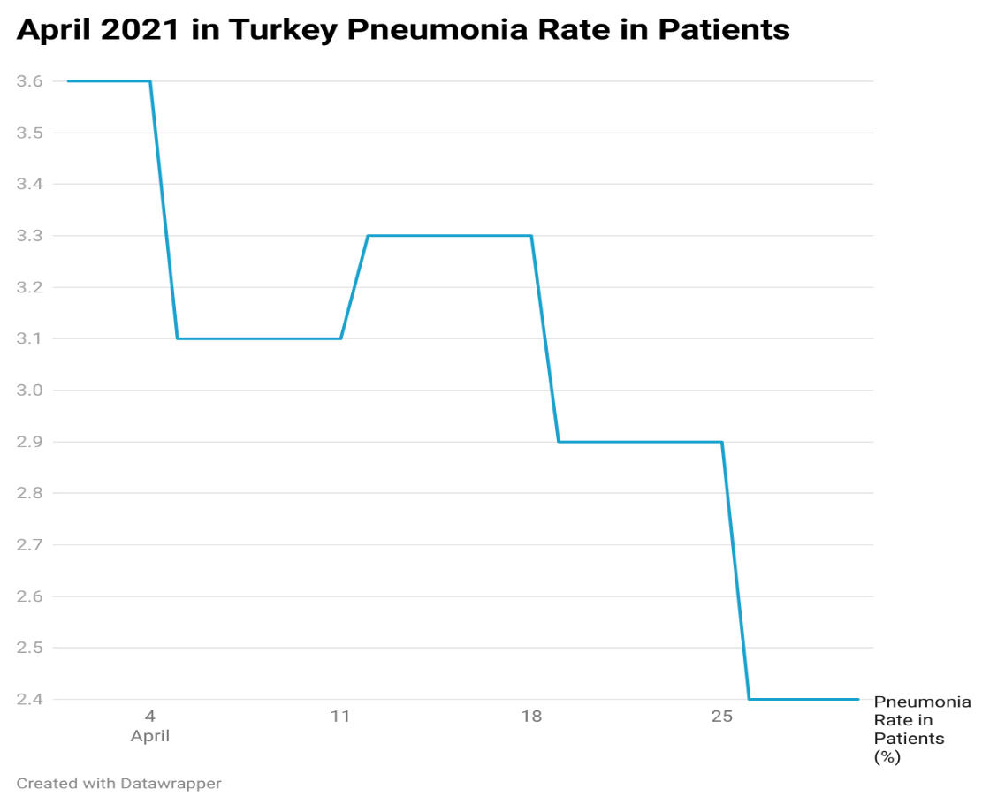  
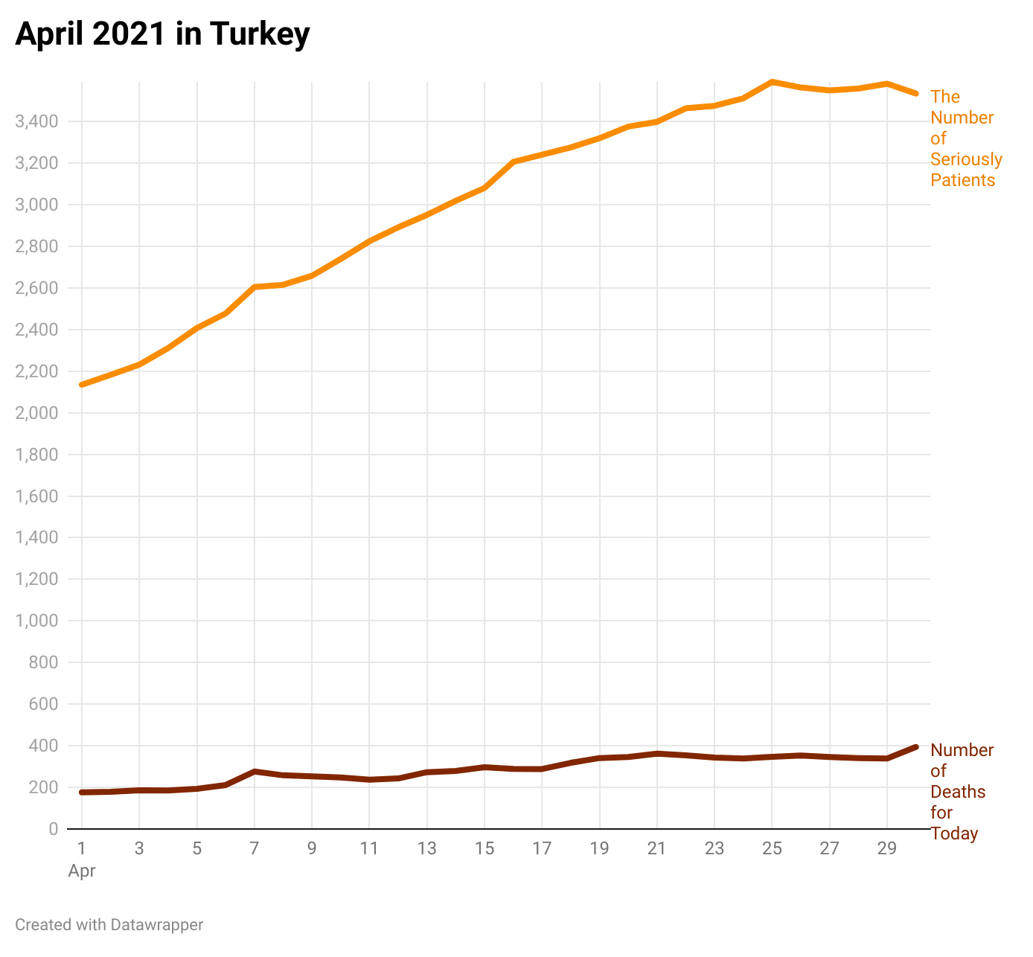  
**Results**  
 During this whole process, after the pandemic got out of control, discussions were starting to increase in Turkey. Members of the media, politicians, healthcare professionals and people could have opposing views. A lot of information was circulating in the news and social media. We could see this most clearly when the Turkish Medical Association and the Ministry of Health expressed opposing views. Many infectious diseases specialists made statements. Those who criticized the measures, did not believe in the coronavirus, did not comply with the measures and acted consciously were in a confusion. Even if Turkey lost control of the pandemic in certain periods, they took very useful measures compared to other countries. But there is much to criticize. The inadequacy of the penalties applied to the measures, the injustices done, the act of even political people without complying with the measures, the measures taken for the tourism sector. All these topics were subjects that people rightly criticized. We can count many political, economic and psychological reasons as the ineffectiveness of the measures taken in Turkey. While examining the hospital occupancy rates, I could see that there is enough physical capacity in the health sector in Turkey. But I can easily say that these capacities and measures are of no use due to other reasons. If the necessary economic measures could be taken, people could stay at home in prosperity and continue to comply with the measures. On the other hand, when we consider the health workers, such social reasons were the increase in the density rates in the hospitals and thus the boredom and other psychological effects of the health workers. Doctors and nurses were unable to heal the sick despite efforts. Crowd and density diminished their ability to work. Turkey did not take any measures for this. When I thought about the measures that could be taken, I realized that there wasn't much. Only in terms of the psychology of healthcare workers could be flexible about working hours. On the other hand, every step to be taken, every precaution to be taken and every treatment to be applied actually carried risks. Currently, there is no visible problem in Turkey regarding hospital occupancy rates. The pandemic is back under control. Although some people say that this is especially the case in the months when the tourism sector is booming, I would like to think that the measures taken have worked. Another issue that can be criticized is the vaccine. Today we are in May of 2021 and vaccination in Turkey is unfortunately still very slow. I think this is the case for many social, economic and political reasons. The pandemic process can only be brought under control with conscious society, measures and vaccines.  
  
  
**Resources**Turkish Medical Association, Coronavirus Pandemic 1st Year Evaluation Report, 29 Mart 2021<https://www.ttb.org.tr/kutuphane/1_yil_rapor.pdf>  
Yanardağ, U., Selçuk, O, (2020), Social Work in the Covid-19 Pandemic Process, Turkish Journal of Social Work Research, Vol 4, No 1, 1-2  
<https://dergipark.org.tr/tr/download/article-file/1133378>   
Republic of Turkey Presidency Digital Transformation Office, Coronavirus World Map  
<https://corona.cbddo.gov.tr/Home/DeathConfirmedRatio>   
Republic of Turkey Ministry of Health Website Covid-19 Information Platform  
<https://covid19.saglik.gov.tr>  
Bozkurt, Y. , Zeybek, Z. , Askin, R. (2020) , Covid-19 Pandemic: Psychological Effects and Therapeutic Interventions, Istanbul Commerce University Faculty of Humanities and Social Sciences, Istanbul, Turkey  
<https://dergipark.org.tr/en/download/article-file/1166182>   
Coronavirus, Explained Documentary, Netflix and Vow  
<https://www.netflix.com/title/81273378>   
Turkey- Response to the Covid-19 Outbreak, World Health Organization Website  
<https://www.euro.who.int/en/countries/turkey/turkey-response-to-covid-19-pandemic>  
World Health Organization, Hospital Readiness Checklist for Covid-19, February 24, 2020   
<https://apps.who.int/iris/bitstream/handle/10665/333972/WHO-EURO-2020-1012-40758-54954-eng.pdf>   
World Health Organization, Strengthening The Health System Response to Covid-19, 18 April, 2020   
<https://apps.who.int/iris/bitstream/handle/10665/332559/WHO-EURO-2020-669-40404-54161-eng.pdf?sequence=1&isAllowed=y>  
**Data Sets:**Presidency of the Republic of Turkey Digital Transformation OfficeRepublic of Turkey Ministry of Health  
World Health Organization  
Turkish Medical Association  
*By finding data from these sources, data sets were created in the most accurate way. These data are still updated. These resources are still used while the pandemic process continues.*